Getting Started with the NI Test Cell Control System

Thank you for purchasing the NI Test Cell Control and Monitoring System. This tutorial will take you step-by-step through setting up your controller and running your first tests. It will also take you through configuring your own test system using NI VeriStand and the INERTIA Add-On for closed loop control.

# Installing NI Software to Operate your Test Cell Control System

1. Note: For additional information about getting started with NI VeriStand, refer to the getting started tutorial: <http://www.ni.com/white-paper/14126/en>
2. Install all of the software found on <http://www.ni.com/veristand/download/>
3. Install the INERTIA Add-On for NI VeriStand. You can download this add-on at <https://lumen.ni.com/nicif/us/evaltlktinertia/content.xhtml>

# Unpacking and Setting up your Test Cell Control System

## Note: Your NI test cell control and monitoring system contains a CompactRIO real-time controller and chassis containing individually marked I/O modules. The type of measurement for each module is labeled on the top of the module, and the pinout for each module is included in the manuals that came with your test cell control system. You should have received your test cell controller with the I/O modules pre-installed. However, if the modules came separately, please see Appendix A for instructions about installing the I/O modules.

1. Set up the PS-15 power supply in accordance with the power supply user manual. The user manual can be found here: <http://www.ni.com/pdf/manuals/372911b.pdf>
2. Connect power to the CompactRIO from the power supply. Insert an Ethernet cable into port 1 of the CompactRIO and connect the other end to either your computer or a router. You should see blinking lights on the Ethernet port of both the computer and CompactRIO.
3. Run the Test Cell Controller Setup utility
   1. Run the Setup Test Cell Controller utility from your start menu or the folder on your desktop
   2. Follow the instructions in the utility to discover your test cell controller and install the appropriate software.
4. Your test cell controller is now configured and ready for use.

# Running a simulated control system

The NI CompactRIO Test Cell Controller includes an NI VeriStand project that performs closed loop control of two simulated motors. You can adjust PID gains, run test sequences, and perform tests on these simulated motors to gain an understanding of how the test cell control system operates. Follow the steps below to perform control of the simulated system.

1. Open NI VeriStand.
2. Open the **Simulated Test Cell Control** project from the Getting Started Window in NI VeriStand.
   1. If the project is not available from the Getting Started Window, select **Browse** and navigate to the project at C:\Users\Public\Documents\National Instruments\NI VeriStand <Year>\Examples\Simulated Test Cell Control.
3. Open the System Explorer by expanding **System Definition File** and double-clicking on **Simulated Test Cell Control.nivssdf**.
4. Select **Controller**. In the right pane of the System Explorer, update the IP address or DNS name to match the IP address of your test cell controller.

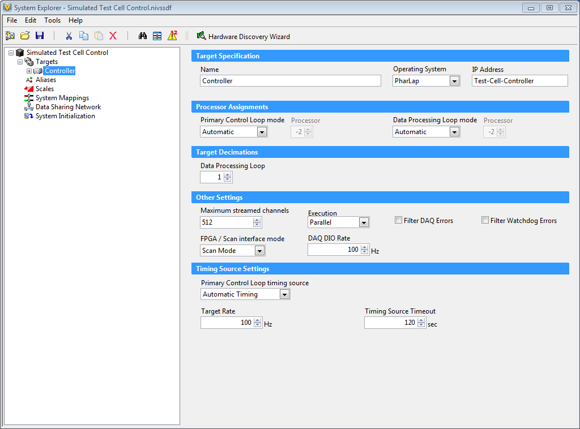

1. Save and close the System Explorer.
2. Deploy the System Definition to your test cell controller by selecting the  button.
3. If not already selected, check the box next to **Close on successful deployment**.

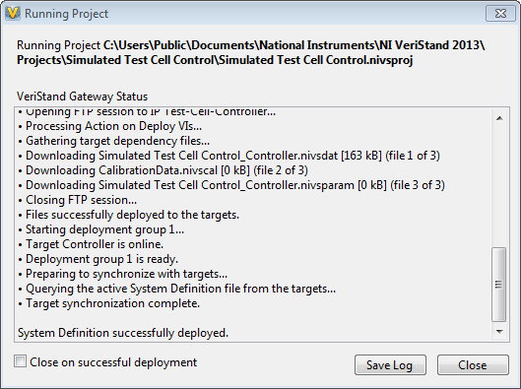

1. When the deployment window displays the message “System Definition successfully deployed,” select **Close**. The Workspace will open.

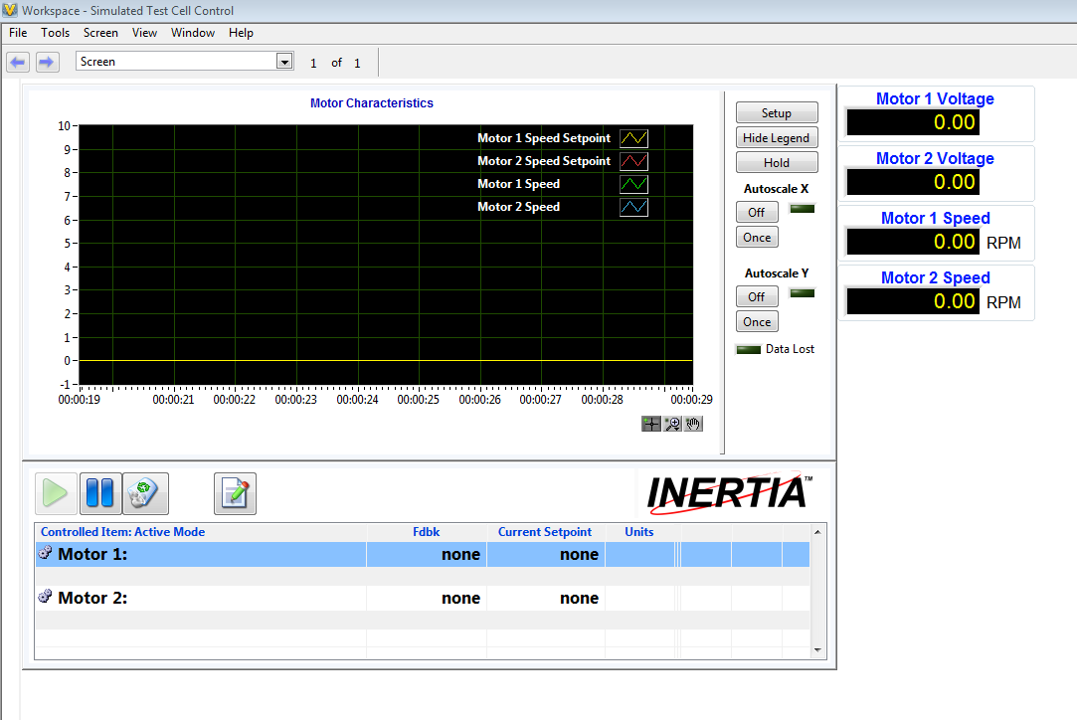

1. Enable speed control on both motors.
   1. Right click on **Motor 1** in the INERTIA workspace control. Select **Switch to Motor 1: Speed Control**.
   2. Right click on **Motor 2** in the INERTIA workspace control. Select **Switch to Motor 2: Speed Control**.

**Note:** Notice that the change does not occur when you select it. The change is marked as “Pending” until you apply the changes. You can apply multiple changes simultaneously by pushing the , or you can apply individual changes by right-clicking on individual control objects and selecting **Apply My Changes**.

* 1. Select the  to apply both changes.

1. The setpoints for both motors are set to 0 by default. You can change the setpoints to control the simulated motors.
   1. Select Motor 1 by clicking anywhere in the Motor 1 row on the workspace control.
   2. Select **Current Setpoint** for the Motor 1. It should turn black.
   3. Enter **8.0** and press the **enter** key. Note that the value hasn’t changed. The change is set to pending. This is to prevent you from making an accidental change to the setpoint. If you make a mistake and want to cancel a setpoint change, right click on the motor and select **Discard my Changes**.
   4. Repeat this process for Motor 2. Set the Motor 2 setpoint to 4.
   5. Adjust the setpoints of the individual motors to new values to verify functionality. The voltage limit on the PID control in this project is 10, so the motor speed will be limited to approximately 13.5 RPM.
2. Open an existing test profile and look at the steps that are included.
   1. Select **Tools🡺 INERTIA Test Editor** to open the INERTIA profile editor tool.
   2. In the profile editor, select **File🡺Open** to bring up the navigation window.
   3. Navigate to **C:\Users\Public\Documents\National Instruments\NI VeriStand <Year>\Examples\Simulated Test Cell Control\Tests** and select **Simulation Test.inertiatest**.

**Note:** Both motors have independent profiles. In these profiles, we are performing ramp functions, dwell functions, and point playback steps as well as using rendezvous steps for test profile synchronization.

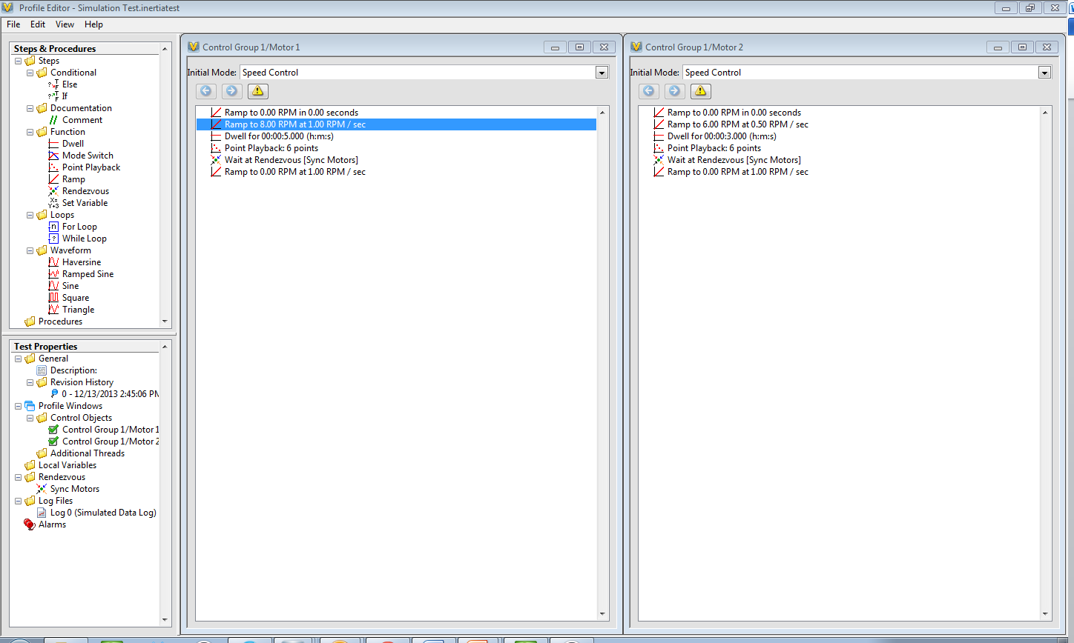

* 1. Double click on each of these functions and observe the dialog boxes used for configuring each item.
     1. Notice that the point playback step shows you a graphical preview of what will be played back.
     2. The point playback can be played back using zero order hold or linear interpolation. The playback of motor 1 uses linear interpolation and the playback of motor 2 uses zero order hold.

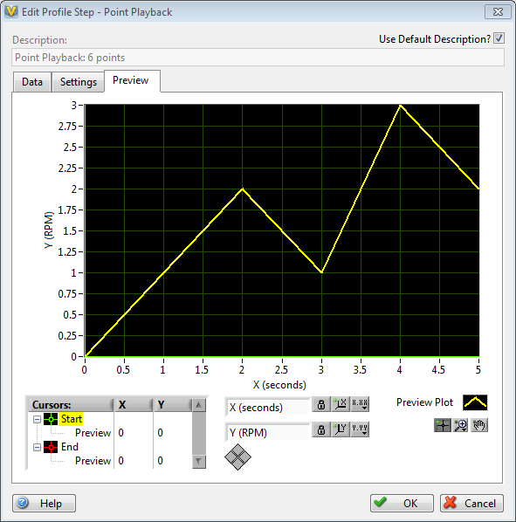 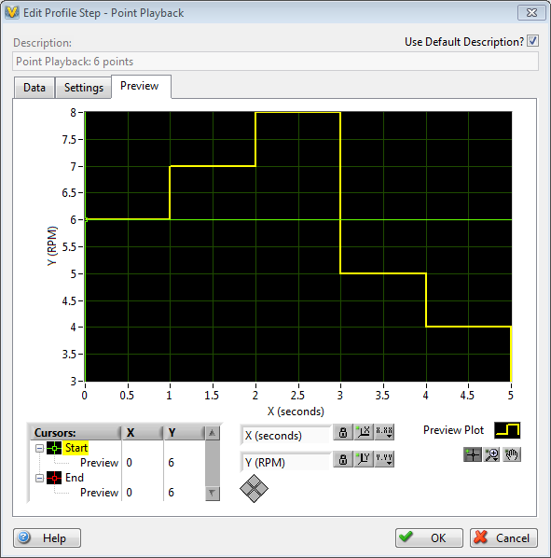

* + 1. The profile includes a rendezvous step. This step aligns both motors. If one motor reaches the rendezvous before the other, the profile will wait until the other motor reaches it. Once both motors have reached the rendezvous, the profile will continue.
  1. This test profile performs data logging. In the Test Properties pane, expand **Log Files** and double-click Log 0 to open the **Edit Log Settings** window.

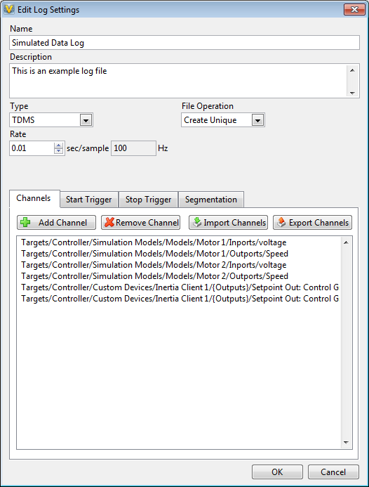

* + 1. In this window, you can select channels to log, start and stop trigger conditions, file segmentation and other file settings.
    2. After you have looked at the configuration options, select **Cancel**.
  1. Close the Profile Editor to return to the Workspace.

1. Execute a test profile and observe the response
   1. Select **Tools🡺 INERTIA Test Exec** to open the INERTIA Header.

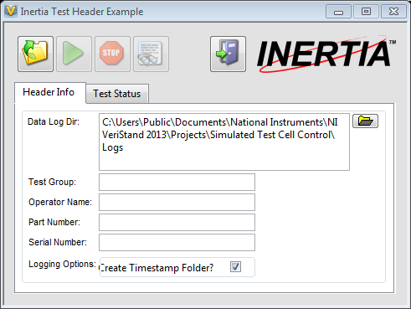

* 1. Select the  and select a file path for your data log.
  2. Select the **Test Status** tab.
  3. Select the and navigate to **C:\Users\Public\Documents\National Instruments\NI VeriStand <Year>\Examples\Simulated Test Cell Control\Tests**. Double-click on **Simulation Test.inertiatest**.
  4. Select the  to begin executing the test profile. The profile will play, changing the motor setpoints. The Test Header will tell you the state of the profile and how long it has been running.
  5. After the profile stops, close the Test Header.

1. View the recorded data in the TDMS file viewer.
   1. Select **Tools🡺 TDMS File Viewer** to open the TDMS File Viewer window.
   2. Select **File🡺Open** and navigate to the data log directory that you specified in the Test Header.
   3. Select **Simulated Data Log** to open the file that you just created.
   4. Select the **Analog Values (graph)** tab and select the individual log channels from the available log channels in the left pane. You can also select multiple channels to view them together on the same graph.

# Verifying I/O functionality

This section of the guide will show you how to verify proper operation of the I/O modules in your controller by connecting real world signals to the controller. You can run a pre-configured NI VeriStand project to create output signals and measure inputs. Follow the steps below to verify I/O functionality on your controller.

1. Connect thermocouples to the thermocouple module in slot 1. The test is configured to connect a J-type thermocouple to TC0 and a K-type thermocouple to TC1. If you do not have one of the thermocouple types, simply skip the step to connect the type that you do not have.
   1. Connect the J-type thermocouple to TC0
      1. Connect the positive lead of the thermocouple to pin 2.
      2. Connect the negative lead of the thermocouple to pin 20
   2. Connect the K-type thermocouple to TC1
      1. Connect the positive lead of the thermocouple to pin 3.
      2. Connect the negative lead of the thermocouple to pin 21
2. Wire modules in slot 2 and 3 to perform a loopback test.
   1. Connect pin 1 on the module in slot 2 to pin 1 on the module in slot 3.
   2. Connect pin 19 on the module in slot 2 to pin 19 on the module in slot 3.
3. Connect bridge circuits to the module in slot 4. The test is configured to connect a full bridge to AI0 and a half bridge to AI1. If you do not have one of the bridge types, simply skip the step to connect the type that you do not have.
   1. Connect your full bridge sensor to AI0.
      1. Connect the EX+ on the sensor to pin 2.
      2. Connect the EX- on the sensor to pin 21.
      3. Connect the V+ on the sensor to pin 3.
      4. Connect the V- on the sensor to pin 22.
      5. Connect the RS+ on the sensor to pin 1.
      6. Connect the RS- on the sensor to pin 20.
   2. Connect your half bridge sensor to AI1.
      1. Connect the EX+ on the sensor to pin 6.
      2. Connect the EX- on the sensor to pin 25.
      3. Connect the V+ on the sensor to pin 7.
      4. Connect the RS+ on the sensor to pin 5.
      5. Connect the RS- on the sensor to pin 24.
      6. You do not need to wire the V- in the half bridge configuration.
      7. Connect the RS- on the sensor to pin 20
4. Perform a loopback test on the DIO module in slot 5.
   1. Connect pin 20 to pin 14.
   2. Connect pin 7 to pin 1.
5. Perform a loopback test on the DIO module in slot 6.
   1. Connect pin 11 to pin 1.
   2. Connect pin 29 to pin 9.
6. Perform a loopback test on the DIO module in slot 7.
   1. Connect pin 11 to pin 1.
   2. Connect pin 29 to pin 9.
7. Open the **IO Test** project from the Getting Started Window in NI VeriStand.
   1. If the project is not available from the Getting Started Window, select **Browse** and navigate to the project at **C:\Users\Public\Documents\National Instruments\NI VeriStand <Year>\Examples\Test Cell Controller\IO Test**.
8. Open the System Explorer by expanding System Definition File and double clicking on **IO Test.nivssdf**.
9. Select Controller and change the IP address to the correct IP address or DNS name for your test cell controller.
10. Close the System Explorer and select to deploy the configuration.
11. In the Workspace, change values on the controls and ensure the corresponding indicators also change.
    1. Slot 3 – AO0 changes should be seen on Slot 2 – AI0.
    2. Slot 5 – DIO 4 changes should be seen on Slot 5 – DIO0.
    3. Slot 6 – DO0 changes should be seen on Slot 6 – DI0.
    4. Slot 7 – DO0 changes should be seen on Slot 7 – DI0.
12. Ensure that you are seeing temperature measurements on the thermocouple test measurements.
13. Ensure that you are seeing measurements on your bridge indicators.

# Creating and configuring a new test cell control project using the Test Cell Template Tool

1. Launch the New Project Template Tool from the start menu or the NI Test Cell Controller folder on the desktop.

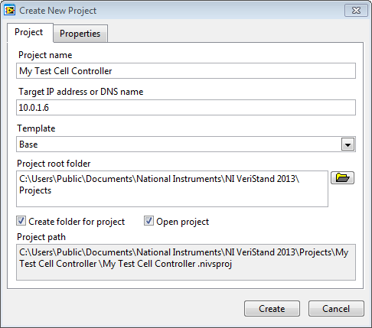

1. Enter the name of your new NI VeriStand project and the IP address of the test cell controller.
2. Select whether you want to use the base template or the XNET template. The XNET template includes support for the optional CAN module. If you do not have the CAN module in slot 8, select the Base Template.
3. Configure INERTIA Control Loops
   1. From the project, select the . This will open the System Explorer window.
   2. Within System Explorer browse Targets 🡺Controller 🡺Custom Devices. Expand Custom Devices to see INERTIA Client 1 and the Scan Engine and EtherCAT custom devices already included.
   3. Navigate to INERTIA Client 1🡺Control Groups🡺Control Group 1 to see to two motor control objects included. You can change the names of the control objects by selecting Motor 1 or Motor 2 and changing the value of the name entry in the right pane of the window.

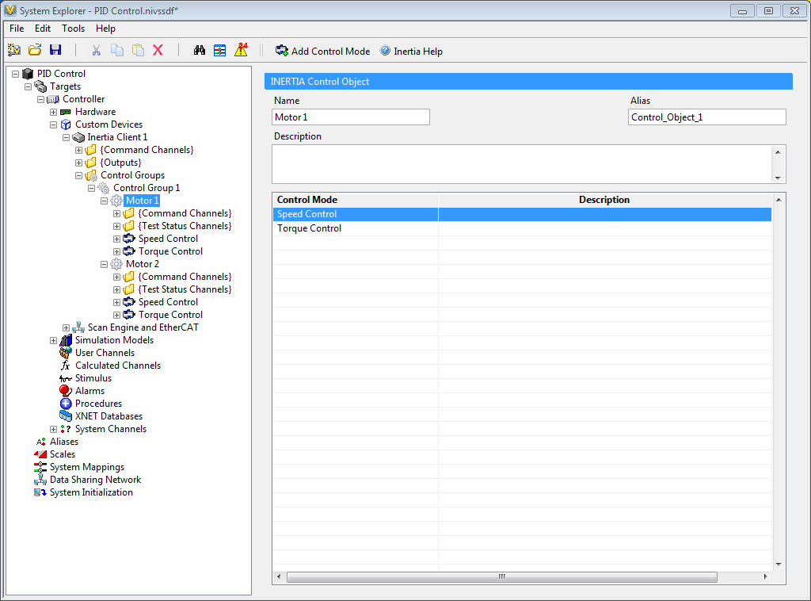

* 1. Expand **Motor 1** to see Speed Control and Torque Control. These control modes determine output and feedback channels. For example, during speed control you would control the input to the motor by monitoring a speed sensor.
     1. Select **Speed Control**. In the output section, choose the channel that will be the output of your PID controller. For example, AO 0 on the NI 9264 if you would like to use AO 0 to control your mechanical object. The channel that you use to perform control will vary based on your configuration.
  2. Expand **Speed Control** and observe that there are three loops, Maximum Limit Loop, Minimum Limit Loop, and Primary Control Loop. The primary control loop is the main PID controller in most cases. However, the maximum and minimum loops, when active, will change the PID settings when the system approaches a predefined limit. All of these loops can be cascaded for more advanced PID control.

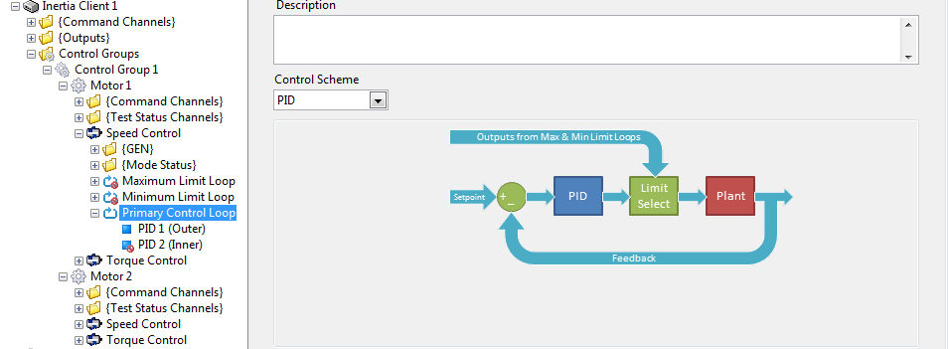

* 1. Expand **Primary Control Loop** to see PID 1 and PID 2. Only PID 1 is active by default. PID 2 will become active if you select a cascaded PID control scheme in the Primary Control Loop window.
  2. Select **PID 1** and choose your feedback channel.
     1. Select the navigation button under Control Mode Mapping to select your feedback channel. For example, AI 1 on the NI 9205 could be used if you would like to monitor AI 1 to monitor feedback from your mechanical object. The channel that you use to monitor feedback will vary based on your configuration.
  3. You have now configured a PID loop using the INERTIA add-on. Repeat this process as needed to configure additional control loops and control modes. Delete any control objects and modes that you do not need.
     1. If you are not using Torque Control, select Torque Control under motor 1 and select the  at the top of the System Explorer window to delete it.
     2. If you are not using Motor 2, select Motor 2 and select the  at the top of the System Explorer window to delete it.
  4. When you are done configuring your system, save and close the System Explorer.

# Performing closed loop control and configuring PID parameters

Now that you have configured your NI VeriStand System Definition, you can deploy it to the controller to perform closed loop control. In this section you will deploy your System Definition and tune the PID gains of your control objects. Every object will require different gain settings. This guide will introduce you to the tools for setting PID gains, but you will have to tune the gains using knowledge of the system.

1. From the NI VeriStand project, select to deploy the system definition to the controller.
2. When the workspace opens you will see items already populated on the workspace. Remap channels and add workspace objects as necessary to see the data that you are interested in.
   1. To remap a workspace object to a new channel, right-click on the Workspace object to bring up the **Item Properties** window.
   2. Select the  to bring up the **Channel Browser** window and select the new channel that you would like to monitor.
   3. Select Ok.
   4. For more information about editing the workspace, watch the video [Building a User Interface with the NI VeriStand Workspace](http://www.ni.com/video/1381/en/).
3. To select control objects from the INERTIA workspace control, select the  to open the PID Control Properties Window.
   1. Highlight **Listbox** in the left pane of the window and double click **on Aliases-Control Objects** in the right pane to bring up the control object selection window.
   2. Select which control objects that you want to control and select **OK**.
   3. Select **OK** on the PID Control Properties Window to close it.
4. Right-click on a control object and select a **control mode** from the menu.
   1. For example, if you have a control object called Motor 1 and one of your control modes is speed control, right click on **Motor 1** and select **Speed Control**.
   2. By default the control will start at 0.

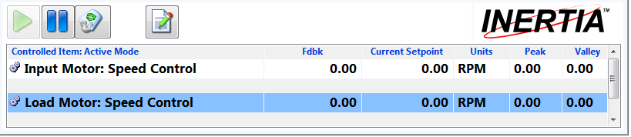

1. Select the **Tools** menu from the top of the Workspace and select INERTIA PID Tuning to open the Control Tuning Utility.
   1. Expand the Control Group down to PID Parameters and select **PID Parameters**.

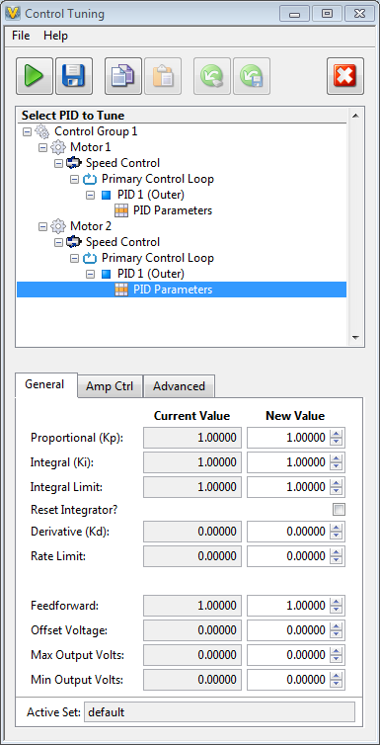

**Note:** The Control Tuning Utility is the tool that enables you to set gain values, control limits, configure amplitude control, and enable dither. It also enables you to select mode transfer decay settings.

* 1. You will need to configure PID gains based on knowledge of your system.
  2. For more information about the Control Tuning Utility and an explanation of the individual setting, select **Help🡺PID Tuning Help** from the Control Tuning Utility menu.

1. You can make manual changes to adjust the setpoints of your control objects. To change control setpoints, follow the steps below.
   1. Select the control object that you want to adjust by clicking anywhere in the control object’s row on the workspace control.
   2. Select the **Current Setpoint** for the control object. It should turn black.
   3. Enter the new setpoint and press the **enter key**. Note that the value hasn’t changed. The change is set to pending. This is to prevent you from making an accidental change to the setpoint.

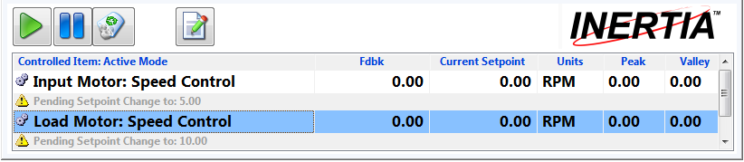

* 1. You can apply multiple changes simultaneously by pushing the , or you can apply individual changes by right-clicking on individual control objects and selecting **Apply My Changes**.
  2. If you have multiple control modes for your control objects, you can switch between control modes by right clicking on the control object and selecting the new control mode.
     1. For example, if you have a motor that has speed control and torque control, you can switch from speed control to torque control by right clicking on the motor and selecting **Switch to Torque Control**.

# Creating and Executing Test Sequences for Test Automation

NI VeriStand and the INERTIA add-on both come with tools to assist you in automating your tests. This section will show you how to use the INERTIA Profile Editor and Test Exec tools.

1. Open the INERTIA Profile Editor by selecting **Tools🡺 INERTIA Test Editor**.
2. Select **File🡺 New Test** to open up the control object selection window.
3. Select the control objects for which you would like to create test profiles.

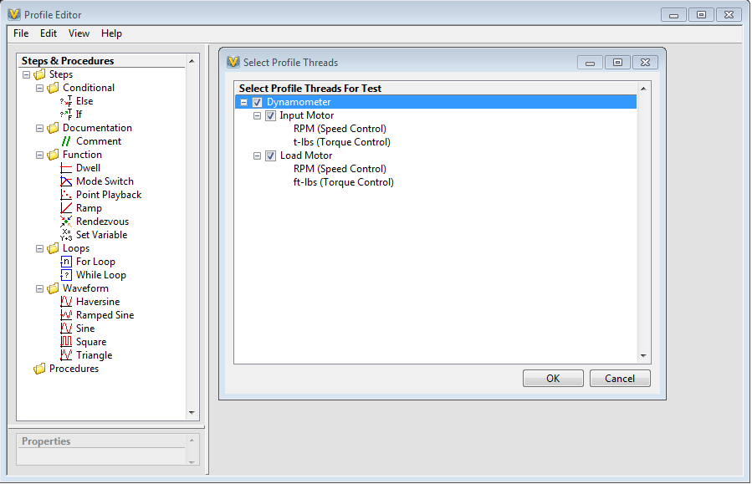

1. You can now drag and drop sequences to control the individual control objects. Test steps will execute sequentially in the order displayed in the Profile Editor. If you have multiple control objects, the steps for the individual object will execute in parallel.
2. For more information about the individual steps in the INERTIA Profile Editor, select **Help🡺Profile Editor Help** to open the INERTIA User Manual with the Profile Editor selected.
   1. Expand Profile Editor and then expand Adding Steps to a Test to see a summary of all of the different steps available in INERTIA.
3. You can use the INERTIA Profile Editor to configure data logging. To configure data logging, follow the steps below:
   1. In the Test Properties pane, right-click on **Log Files** and select **Add Log File**.
   2. Double-click on the new file to open the Edit Log Settings window.

**Note:** This window can be used to configure your data logs. You can specify channels to log, logging rate, triggering, and file segmentation among other things. For detailed information about data logging configuration options, go to **Help🡺Profile Editor Help** and navigate to **Profile Editor🡺Test Properties🡺 Edit Log Settings**.

* 1. After you have configured the log file, select **OK**. The test profile will now create a data log when it executes.

# Additional Resources

This guide has given you an introduction to NI VeriStand and the INERTIA add-on for test cell control and monitoring. NI VeriStand has many additional features including advanced stimulus generation, automated data logging and integration with NI DIAdem for post processing and report generation, and simulation model integration. Below are some links to additional resources to help you familiarize yourself NI VeriStand.

[NI VeriStand Demonstration Videos](http://www.ni.com/veristand/demos/) – This series of videos gives you a quick introduction to NI VeriStand and walks you through configuring your real-time test system and creating a user interface.

[Getting Started with NI VeriStand](http://www.ni.com/white-paper/14126/en/) – This document introduces you to some of the core features of NI VeriStand. It also shows you how to configure an NI VeriStand project without using the INERTIA Project Configuration tool.

[NI VeriStand Tutorial](https://lumen.ni.com/nicif/us/ekitvsdld/content.xhtml) – Walk through building a real-time test system from scratch. Configure simulated I/O, create real-time stimulus profiles, and automate data logging and analysis in this guide.

[Getting Started with NI-XNET for NI VeriStand and NI LabVIEW](http://www.ni.com/tutorial/14706/en/) - The NI-XNET family of products includes a series of high-performance CAN, LIN, and FlexRay interfaces. These interfaces are optimized for applications that require real-time, high-speed manipulation of hundreds of CAN, LIN and FlexRay frames and signals, such as HIL simulation, rapid control prototyping, bus monitoring, and more. This document walks through the initial steps to get started with NI-XNET interfaces for NI VeriStand

[Combining NI VeriStand Software and NI DIAdem Software to Improve Real-Time Test Data Management](http://www.ni.com/white-paper/14830/en/) - NI VeriStand can be used with DIAdem to quickly and easily log data, perform postprocessing, and generate reports—all from the NI VeriStand workspace. Learn more about how these two tools can be used together to improve your real-time testing efficiency.

Appendix A

Below is a list of I/O modules that are included with your test cell controller. These modules must be installed in the proper slots to ensure that the sample projects work properly. Please verify module configuration if you encounter deployment errors on your system.

|  |  |
| --- | --- |
| Slot | Module |
| 1 | NI 9214 – Thermocouple module |
| 2 | NI 9205 – Analog input module |
| 3 | NI 9264 – Analog output module |
| 4 | NI 9237 – Simultaneous bridge module |
| 5 | NI 9401 – High speed digital I/O module |
| 6 | NI 9375 – Digital I/O module |
| 7 | NI 9375 – Digital I/O module |
| 8 | Optional: NI 9862 – High speed CAN module |